**Week 2 – Initial Design**

Published by Huixin on February 14, 2021

The team had our initial ideation based on the research last week. With the team goal of giving high school students education on financial literacy and rebuild their trust in banking services, we generated three ideas: Bodega Tycoon, Bodega Story, and Financial Trivia. After discussing with the client, we chose to combine the Bodega Tycoon idea with some storytelling elements to ensure the educational and emotional impact of the design. We kept developing the idea through team meetings and the composition box workshop.

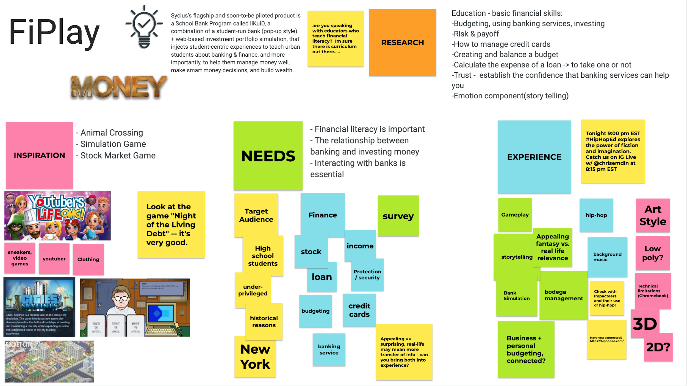

Let’s now dig into the details of our initial game idea. For the financial gameplay component, the player will run a bodega. They will manage inventory and decide which items to stock and sell. The player’s goal is to expand the business by reinvesting their revenue into upgrades and improvements to the bodega. There are three key financial interactions in the game: **Budgeting, Banking and Investment.** The player will gain confidence with each interaction as they progress through the stages of the game.

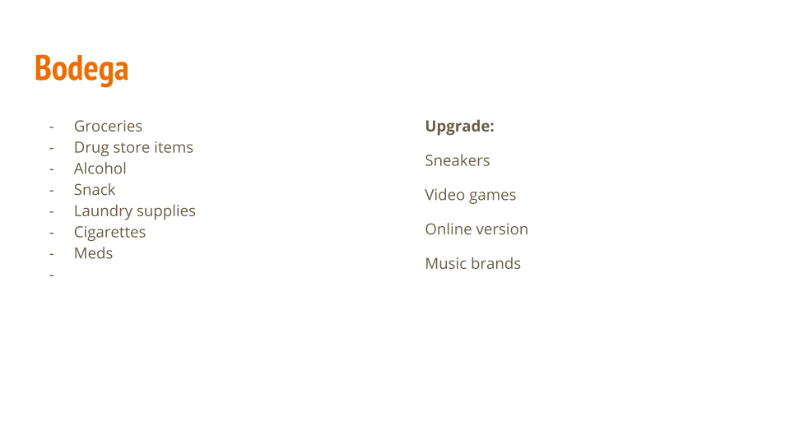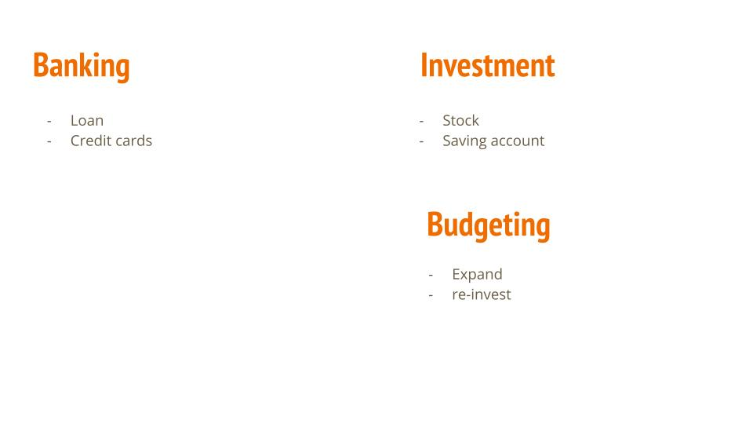

We will incorporate the storytelling element through the community component in the game. Real-life NYC bodegas are more than just corner stores: they are a crucial support structure for the neighborhood. Through running a bodega, the player will meet neighbors and build relationships with regular customers. After making money, the player will be able to give back by helping their neighbors through difficult times, or even donating to local institutions. As game designers, we want to make sure that the game is down-to-earth and resonates emotionally with our target audience.

We will also design random events in the game to make it more realistic and engaging, like power outages, rising rents, and different weather conditions.

We also plan to embrace hip-hop culture to better connect with the target audience. Some tutorials or financial literacy education might be delivered through a radio or podcast ingame. There will also be a music player, allowing you to change the game’s background music

